

***A Mini-Project Report On***

**“Plant disease detection ”**

***Submitted By***

**Joel Randive**

**PRN: 1132210015**

**Vipul Doiphode**

**PRN: 1132210545**

**Shivam Satav**

**PRN: 1132210324**

**Omkar Sawant**

**PRN: 1132210194**

**Aditi Akadkar**

**PRN: 1132210349**

**S.Y. M.Sc. (Data Science and Big Data Analytics)**

**School of Computer Science**

**Faculty of Engineering and Technology**

**Dr. Vishwanath Karad MIT – World Peace University**

**Pune - 411038**

**Academic Year 2022-2023**

**Nov - 2022**

**Dr. Vishwanath Karad MIT WORLD PEACE UNIVERSITY, PUNE**

**SCHOOL OF COMPUTER SCIENCE**

**Certificate**

This is to certify that

**Joel Randive**

**PRN: 1132210015**

Of **M.Sc. (Data Science and Big Data Analytics)** successfully completed his/her

Mini-Project in

**Dr. Vishwanath Karad MIT WORLD PEACE UNIVERSITY, PUNE**

**SCHOOL OF COMPUTER SCIENCE**

**Certificate**

This is to certify that

**Vipul Doiphode**

**PRN: 1132210545**

Of **M.Sc. (Data Science and Big Data Analytics)** successfully completed his/her

Mini-Project in

**Dr. Vishwanath Karad MIT WORLD PEACE UNIVERSITY, PUNE**

**SCHOOL OF COMPUTER SCIENCE**

**Certificate**

This is to certify that

**Shivam Satav**

**PRN: 1132210324**

Of **M.Sc. (Data Science and Big Data Analytics)** successfully completed his/her

Mini-Project in

**Dr. Vishwanath Karad MIT WORLD PEACE UNIVERSITY, PUNE**

**SCHOOL OF COMPUTER SCIENCE**

**Certificate**

This is to certify that

**Omkar Sawant**

**PRN: 1132210194**

Of **M.Sc. (Data Science and Big Data Analytics)** successfully completed his/her

Mini-Project in

**Dr. Vishwanath Karad MIT WORLD PEACE UNIVERSITY, PUNE**

**SCHOOL OF COMPUTER SCIENCE**

**Certificate**

This is to certify that

**Aditi Akadkar**

**PRN: 1132210349**

Of **M.Sc. (Data Science and Big Data Analytics)** successfully completed his/her

Mini-Project in

**“Plant disease detection”**

to our satisfaction and submitted the same during the academic year 2021 - 2022 towards the partial fulfilment of degree of  **Master of Science in Data Science and Big Data Analytics** of Dr Vishwanath Karad MIT World Peace University under the School of Computer Science, MIT WPU, Pune.

**Prof. Dr. Shubhalaxmi Joshi Prof. Surabhi Thatte Prof. Surabhi Thatte**

**Associate Dean Program Head Assistant Professor**

**Faculty of Science School of Computer School of Computer**

**Science Science**

**MITWPU MIT WPU MIT WPU**

**ACKNOWLEDGEMENT**

In the accomplishment of this project, I would like to express my special thanks of gratitude to my teachers **Prof. Vishal Pawar**, School of Computer Science, Dr. Vishwanath Karad MIT World Peace University whose valuable guidance has been the ones that helped me patch this project and make it full proof success. **Joel randive** suggestions and instructions have served as the major contributor towards the completion of the project.

As we were working in a group, I would like to thank my group members for their fabulous support throughout the completion of the project. We learned a lot of things during this period, as it was hard to work in this time of adversity; we were in touch with each other throughout the period and shared everything which was important from the aspect of our project. As this project was completed by staying at home, I would also like to thank our families for their cooperation and for providing facilities to us.

**Joel randive**

**PRN. 1132210015**

**Contents**

|  |  |
| --- | --- |
| **Introduction** |  |
| Domain Name | 4 |
| Motivation | 4 |
| Problem Statement | 4 |
|  |  |
| **Literature Survey** | 5 |
|  |  |
| **Solution Design** |  |
| Solution Approach | 7 |
| Technology Stack | 7 |
| Design Model | 8 |
|  |  |
| **Solution Implementation and Results** |  |
| Obtaining Data | 11 |
| EDA | 13 |
| Pre-Processing | 14 |
| Algorithms Used | 16 |
| Results | 20 |
| **Conclusion and Future Work** |  |
| Conclusion | 21 |
| Future Work | 21 |
| **References** | 22 |

**Image Classification (Crop Disease Detection)**

1. **Motivation:**

Food Security Remains Threatened by a number of factors including climate change, Plant diseases are not only a threat to food security but have consequences for smallholder farmers, Who’s livelihood depends on healthy crops. Therefore this project by using deep learning and computer vision solves the following issue by predicting the lesion in the crop beforehand. This helps the farmer to identify the defective crop and improves the quality and quantity in the Farming

**Problem Statement:**

Identification of the plant diseases is the key to preventing the losses in the yield and quantity of the agricultural product. The studies of the plant diseases mean the studies of visually observable patterns seen on the plant. Health monitoring and disease detection on plant is very critical for sustainable agriculture. It is very difficult to monitor the plant diseases manually. It requires tremendous amount of work, expertise in the plant diseases, and also require the excessive processing time. Hence, image processing is used for the detection of plant diseases. Disease detection involves the steps like image acquisition, image pre-processing, image segmentation, feature extraction and classification. The occurrence of plant diseases has a negative impact on agricultural production. If plant diseases are not discovered in time, food insecurity will increase . Early detection is the basis for effective prevention and control of plant diseases, and they play a vital role in the management and decision-making of agricultural production. In recent years, plant disease identification has been a crucial issue.

Problem solution



In recent years, deep learning technology in the study of plant disease recognition made more progress. Deep learning (DL) technology in the face of the user is transparent, the researchers of plant protection and statistics professional level is not high, can be automatically extracted image features and classification of plant disease spot, eliminating the traditional image recognition technology of feature extraction and classifier design a lot of work, can express original image characteristics, has the characteristics of the end-to-end. These characteristics make deep learning technology in plant disease recognition-obtained-widespread attention This is due to three factors: the availability of larger datasets, the adaptability of multicore graphics processing units (GPUs), and the development of training deep neural networks and supporting software libraries, such as the computing unified device architecture (CUDA) from NVIDIA.

Technology Stack:

Using React-native for the building an android application where in the farmer can scan the photo of the crop , moving on the image will move forward through the pipeline which is image pre-processing phase which will make use of computer vision- python(keras,tensorflow). After the pre-processing phase , the preprocessed image will be ready for the modelling phase in where the image will be run through the model. The model consist of transfer learning technique , GoogleNet is used as a base and SVM as the classifier.

Design Model:

Data Ingestion(React native application)

Modelling

(Deep Leaning

Convolution,

Transfer Learning,

Svm)

Image Pre-processing

(CV2 Python)

Obtaining Data:

For the model training phase the data is taken from kaggle. By using python,cv2,keras,numpy,tensorflow the image is manipuated , preprocessed and made ready for the modelling phase.

The plant disease as the following classes in which the crop will be classified:

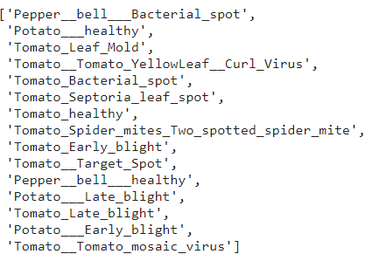

The following is the sample of the entire Image dataset which shows Tomato_Bacterial_spot .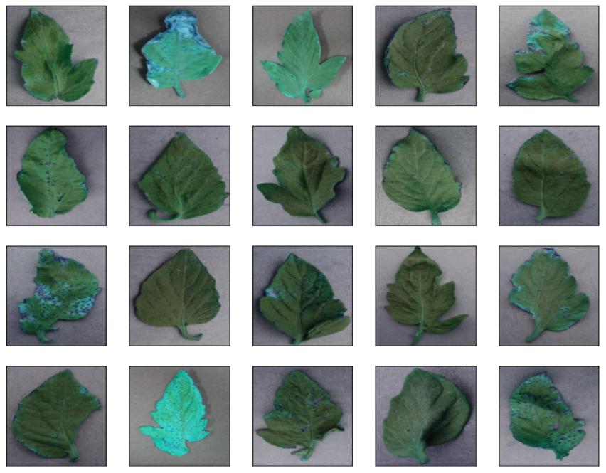

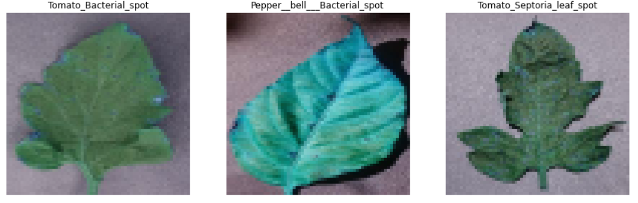

For validation using the android application made using react-native we can scan the crop using the phone’s camera

EDA

**Plotting Image Size**

Consistent image size is crucial for deep learning, mismatched matrices will bring project to a quick stop. Visualizing raw image size can also help understand dataset better.

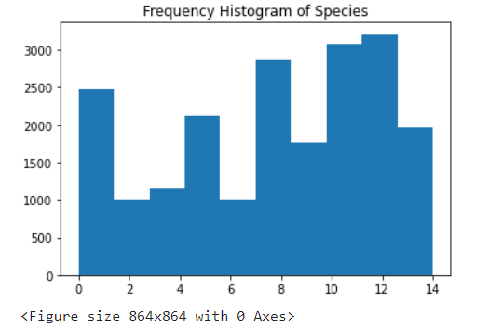

Pre-processing:

As the data was taken from Kaggle during the learning phase the data

was already pre-processed. Though the data during the validation phase the data will come in raw.

The Image hence is converted into gray-scale reducing it’s dimension hence reducing the computation on it and storage.

Algorithms Used:

The modelling phase is done using the transfer learning technique.

For the base Dense Net is used.For the head and classification SVM is used.

Results:

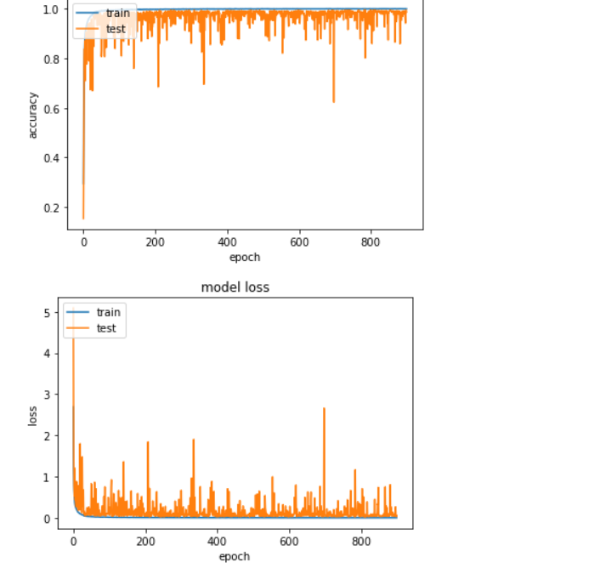

At the final epoch we go an accuracy and val_accuracy of 99.2 and 92.49% respectively using the DenseNet and SVM architecture

Conclusion:

The importance of collecting large datasets with high variability, data augmentation, transfer learning, and visualization of CNN activation maps in improving classification accuracy, and the importance of small sample plant leaf disease detection was performed in this project.

DL frameworks have good detection effects on their datasets, but the effects are not good on other datasets, that is the model has poor robustness. Therefore, better robustness DL models are needed to adapt the diverse disease datasets.

Further Work:

Using more advance architecture requires high computation and a larger dataset.

This can be fulfilled using cloud. The further approach can be hosting this problem statement on the cloud with advance architecture and making use of more additional data for the learning purpose.